Chapter 9, Problem 47.
In the circuit shown in Fig. 9.54, determine the value of i_{s}(t).

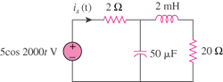

Figure 9.54
For Prob. 9.47.

